Step 4 - Install ROS-Ag lawn tractor simulator

Goto https://github.com/ros-agriculture/ros_lawn_tractor

(There was a Pure Pursuit option in the Google Drive, but it is no longer there. https://drive.google.com/open?id=1xIZZrAvjdeUaAolCRMZPGvgHo_0h7M0uH14-Q9gnoiw
)
Follow the instructions (duplicated here):
- $ cd catkin_ws/src
- $ git clone https://github.com/ros-agriculture/ros_lawn_tractor.git
- $ git clone https://github.com/bsb808/geonav_transform.git
- cd ..
- $ rosdep update
- $ rosdep install -y --from-paths . --ignore-src --rosdistro ${ROS_DISTRO}
- $ sudo apt-get install python-catkin-tools
- $ catkin build
- $ roslaunch lawn_tractor_sim lawn_tractor_sim.launch

Optional - If you have previously modified the ROS_MASTER_URI in your .bashrc file to have a separate controller tractor you will need to update .bashrc so the ROS_MASTER_URI is set to your laptop performing the simulation. ( Enter $ nano ~/.bashrc) or find .bashrc in /home/al and open with Sublime)
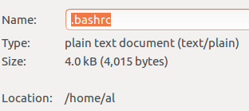

      - Comment out tractor_aj
      - enable ROS_MASTER_URI controller for local laptop simulation
      - Save and $ source ~/.bashrc
      - 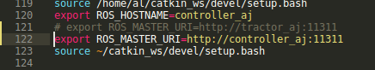

# if you want the laptop (aka the controller) to be the master, when testing ROS using the laptop, comment out the tractor;
# export ROS_MASTER_URI=http://tractor_aj:11311
# if you are running the tractor it needs to be the master so comment out the controller/laptop;
# export ROS_MASTER_URI=http://controller_aj:11311
# if you are running the simulator in Docker the master needs to be localhost; The controller/laptop and tractor should be commented out.
# Docker wants ROS_MASTER_URI=http://localhost:11311
export ROS_MASTER_URI=http://localhost:11311

source /opt/ros/kinetic/setup.bash
source /home/al/catkin_ws/devel/setup.bash
export ROS_HOSTNAME=controller_aj
# if you want the laptop (aka the controller) to be the master, when testing ROS using the laptop, comment out the tractor;
# if you are running the tractor enable it as the master; Comment out the controller/laptop;
export ROS_MASTER_URI=http://tractor_aj:11311
# if you are running the tractor enable it as the master; Comment out the controller/laptop;
# export ROS_MASTER_URI=http://controller_aj:11311
# if you are running the simulator in Docker enable localhost as the master; The controller/laptop and tractor should be commented out.
# export ROS_MASTER_URI=http://localhost:11311
source ~/catkin_ws/devel/setup.bash

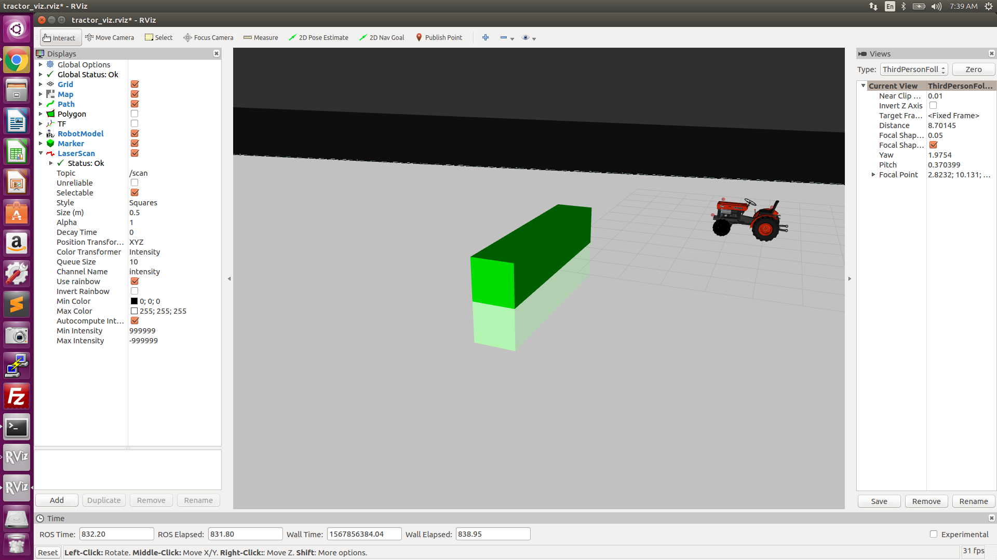

- The tractor is now waiting for a 2D nav goal. You can send the vehicle on missions by using the 2D nav goal function in rviz. Click on the 2D Nav Goal button. Then click in the world where you want the tractor to end and drag the arrow in the direction you want the robot to end in. Once released you should see the tractor move to that location and heading.
- Warning: Obstacle detection is not enabled so it will not maneuver around the green block

RViz keystroke controls
- Left mouse button: Click and drag to rotate around the focal point.
- Middle mouse button:
  - Scrollwheel - Roll forward and back for zoom
  - Click and drag to move the focal point in the plane
- Right mouse button: Click and drag to zoom in/out of the focal point. Dragging up zooms in, down zooms out.

Test drive using gamepad

Confirm gamepad input:
- Before connecting the gampad run $ ls /dev/input/
- Now connect the gamepad and run the same command $ ls /dev/input/
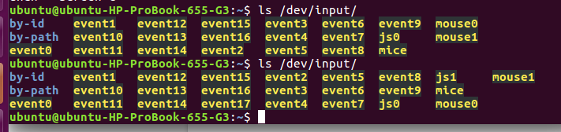
- For me the new device is “js1” # I’m told, but have not confirmed, if js0 is present that it is the accelerometer on the laptop.
- Try $ sudo jstest /dev/input/js1 or $ sudo jstest /dev/input/js0
- You should get output similar to the following. I like adjusting the window width so “Buttons” appears in column 1 of the window or wide enough so the screen does not move when the values change.
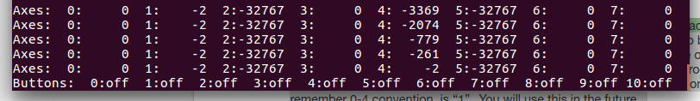

- When you use the joystick buttons you should see the values change.
- Later we will be sending /cmd_vel twist messages. That node has a “deadman” button built in which means to send a command you will be pressing two buttons simultaneously (i.e. the deadman button and a command like the throttle or steering). Often the default setup is button 4 is the deadman. Test the various buttons and confirm if the left, top button on the front of the controller triggers “4” on and off.
- $ ctrl + C to stop the process

On Laptop, where joystick will be connected, install package to transfer data from /joy to /cmd_vel:
- We will be using https://github.com/da(https://github.com/danielsnider/simple_drive/blob/master/src/simple_drive/drive_teleop.py)nielsnider/simple_drive, but this has been modified somewhat so we will use the forked version that is located at https://github.com/ros-agriculture/tractor_teleop
- Because we need to change the code we need to load this into our local catkin_ws
- $ cd catkin_ws/src
- $ git clone https://github.com/ros-agriculture/tractor_teleop.git
- cd ..
- In drive_teleop.launch
- 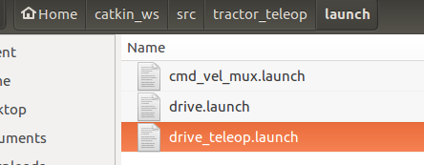
- Make sure “<param name="autorepeat_rate" value="20" />” after the line “<param name="joy_dev" value="$(arg joy_dev)" />” is there.
- Also update the Max speed setting for forward and reverse. I would suggest 1.5 for both which is 1.5 meters per seconds.
  - 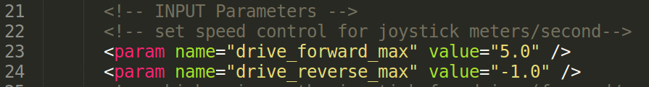
<launch>
<env name="ROSCONSOLE_FORMAT" value="[${severity}][${thread}][${node}/${function}:${line}]: ${message}"/>

<!-- Joystick Device Argument -->
<arg name="joy_dev" default="/dev/input/js0"/>

<!-- Joy Node -->
<node pkg="joy" type="joy_node" name="joy_drive" clear_params="true" output="screen" respawn="true" >
<param name="joy_dev" value="$(arg joy_dev)" />
<param name="autorepeat_rate" value="20" />
<param name="deadzone" value="0.12" />
<!-- OUTPUT TOPICS -->
<remap from="joy" to="joy" />
</node>

<!-- Teleoperation Node -->
<node pkg="simple_drive" type="drive_teleop" name="drive_teleop" clear_params="true" output="screen" respawn="true">
<param name="servo_pan_speed" type="int" value="5"/>
<param name="servo_pan_max" type="int" value="160"/>
<param name="servo_pan_min" type="int" value="0"/>
<!-- INPUT TOPICS -->
<remap from="joy" to="joy" />
<!-- OUTPUT TOPICS -->
<remap from="teleop/cmd_vel" to="teleop/cmd_vel" />
<remap from="servo_pos" to="servo_pos" />
<remap from="move_base/cancel" to="move_base/cancel" />
</node>
</launch>

Decide what launch file you want the “start” button to launch
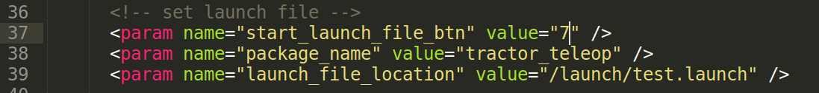
- Confirm cmd_vel_mux.launch has the correct cmd_vel destination
  - <!-- INPUT TOPICS -->
  - <remap from="teleop/cmd_vel" to="teleop/cmd_vel" />
- Confirm drive_teleop.launch has the correct cmd_vel destination
  - <!-- OUTPUT TOPICS -->
  - <remap from="teleop/cmd_vel" to="teleop/cmd_vel" />
- The original program from Daniel Snyder was written for a skid steer vehicle and mixed both joystick readings together. One of the changes with tractor_teleop is changing how the values are adjusted. With Ackerman we do not want to mix values. Matt also removed an estop service call so this will work in simulation. If you want the estop you would add the commented code below. (see Matt for help).
- 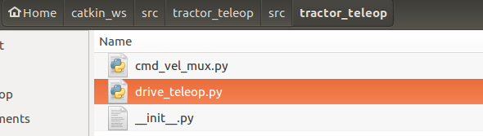
#!/usr/bin/python
# python node than listens to joy node and publishes to cmd_vel_mux
# it will also call the relay service (e.g. you want to shut down the tractor
import rospy
import subprocess
import time

from sensor_msgs.msg import Joy
from std_msgs.msg import Float32
from geometry_msgs.msg import Twist
from actionlib_msgs.msg import GoalID
# from lawn_tractor.srv import * # not able to run this in simulation

class DriveTeleop:
def __init__(self):
self.cmd_vel_pub = rospy.Publisher("teleop/cmd_vel", Twist, queue_size=1)
self.goal_cancel_pub = rospy.Publisher("move_base/cancel", GoalID, queue_size=1)
self.joy_sub = rospy.Subscriber("joy", Joy, self.on_joy, queue_size=1)

# self.service_relay_client = rospy.ServiceProxy("/relay_cmd", relayCmd) # will fail in simulation
# self.service_relay_client_object = relayCmdRequest() # will fail in simulation

def on_joy(self, data):

# Drive sticks
if data.buttons[4]: # deadman 5 button
angular_vel = data.axes[0]
linear_vel = data.axes[1]

# Publish Twist
twist = Twist()
twist.linear.x = linear_vel
twist.angular.z = angular_vel
self.cmd_vel_pub.publish(twist)

# EStop
if data.buttons[1]: # 2 button
rospy.loginfo('Estop tractor')
# self.service_relay_client_object.channel = 27
# self.service_relay_client_object.state = 0
# result = self.service_relay_client(self.service_relay_client_object)
# if result.success == True:
# self.engine_off = 1
# self.tractor_ready = 1

# Cancel move base goal
if data.buttons[2]: # X button - will cancel an autonomous path if one has been programmed
rospy.loginfo('Cancelling move_base goal')
cancel_msg = GoalID()
self.goal_cancel_pub.publish(cancel_msg)

def main():
rospy.init_node("drive_teleop")
# rospy.wait_for_service("/relay_cmd")
controller = DriveTeleop()
rospy.spin()

- The statements commented out are because they drive a relay board that is not implemented in the simulator.
- From ~/catkin_ws, $ catkin build
- $ source devel/setup.bash
- $ rospack find joy # returns /opt/ros/kinetic/share/joy
- $ rospack find tractor_teleop # returns /home/al/catkin_ws/src/tractor_teleop

Start joy_input to transfer data to cmd_vel:
- Ctrl+Alt+T, $ roslaunch tractor_teleop cmd_vel_mux.launch
- Ctrl+Alt+T, $ roslaunch tractor_teleop drive_teleop.launch joy_dev:=/dev/input/js0
- Note: drive_teleop.launch has as a default: <arg name="joy_dev" default="/dev/input/js0"/> If your joystick is on js1 you can either change the launch file or adjust the argument.
- Alternatively, the command below has both of the above commands combined
  - $ roslaunch tractor_teleop drive.launch
- If you hold the deadman button and move the joystick there will be output on /cmd_vel and vehicle should move.
- You should be able to open a window and run $ rostopic echo cmd_vel and see output.
- The package is programmed with a deadman switch which is required to be pressed at the same time the left joystick is being moved. Without using both simultaneously the messages will not be sent to the vehicle. This is a safety design when operating in the real world.

Additional control and visualization tools:
- Drag the rvis screen to the left so it occupies only ½ of the page
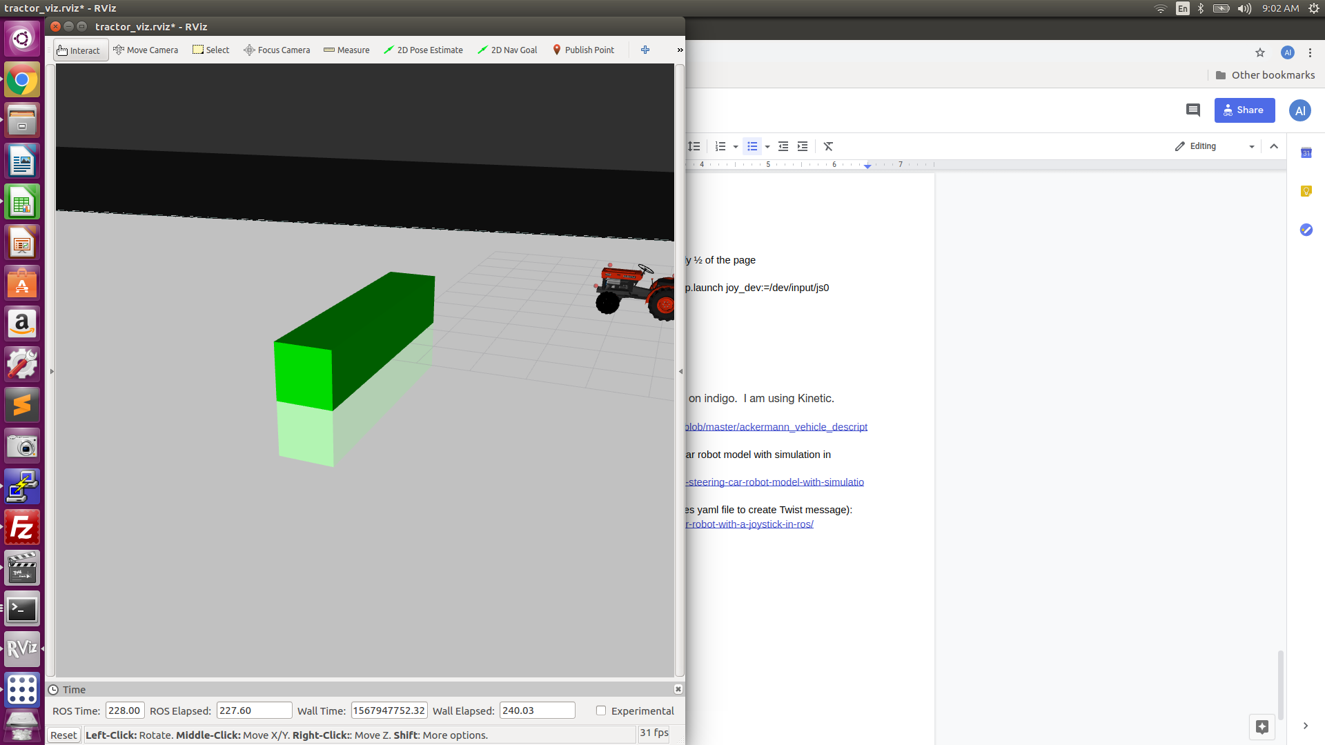

- Ctrl+Alt+T, $ rqt
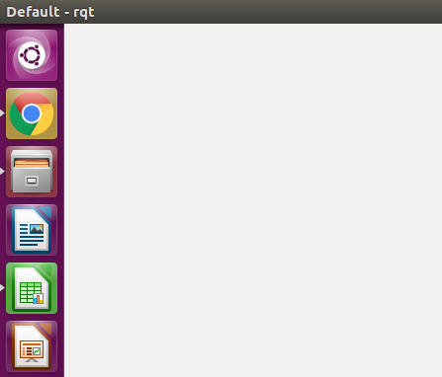

- Choose Plugins -> Robot Tools -> Robot Steering
- Drag the window all the way to the right
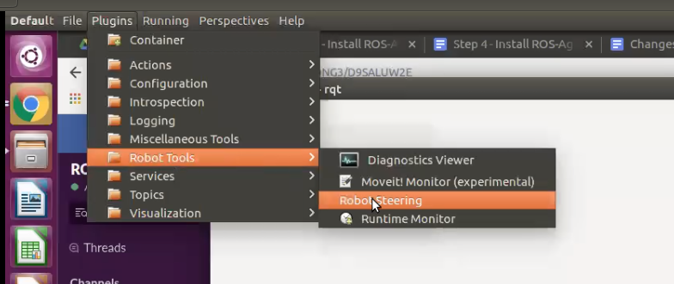
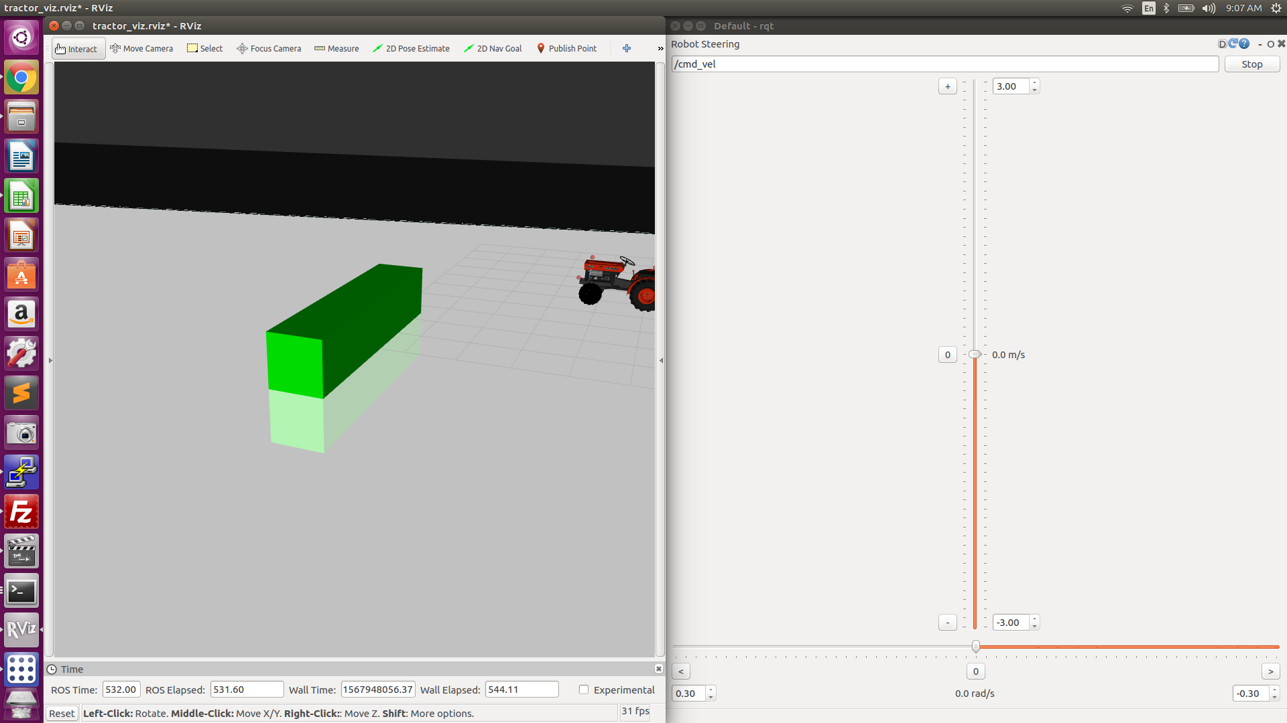
- You can now adjust the slide bars and send cmd_vel command using this interface
- Plugins -> Visualizations -> Plot will allow you to subscribe and visualize (i.e. plot) rostopics
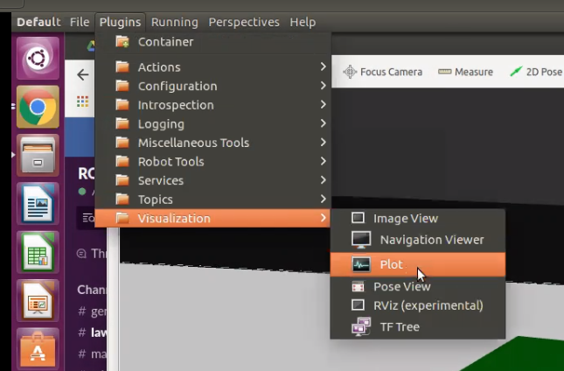
- Plugins -> Topics -> Topic Monitor lets you drag and drop the topics you are interested in
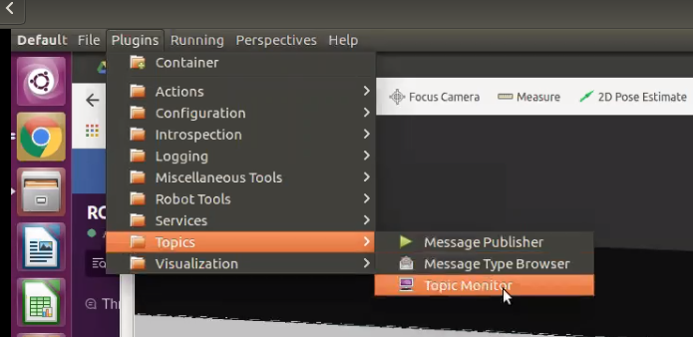

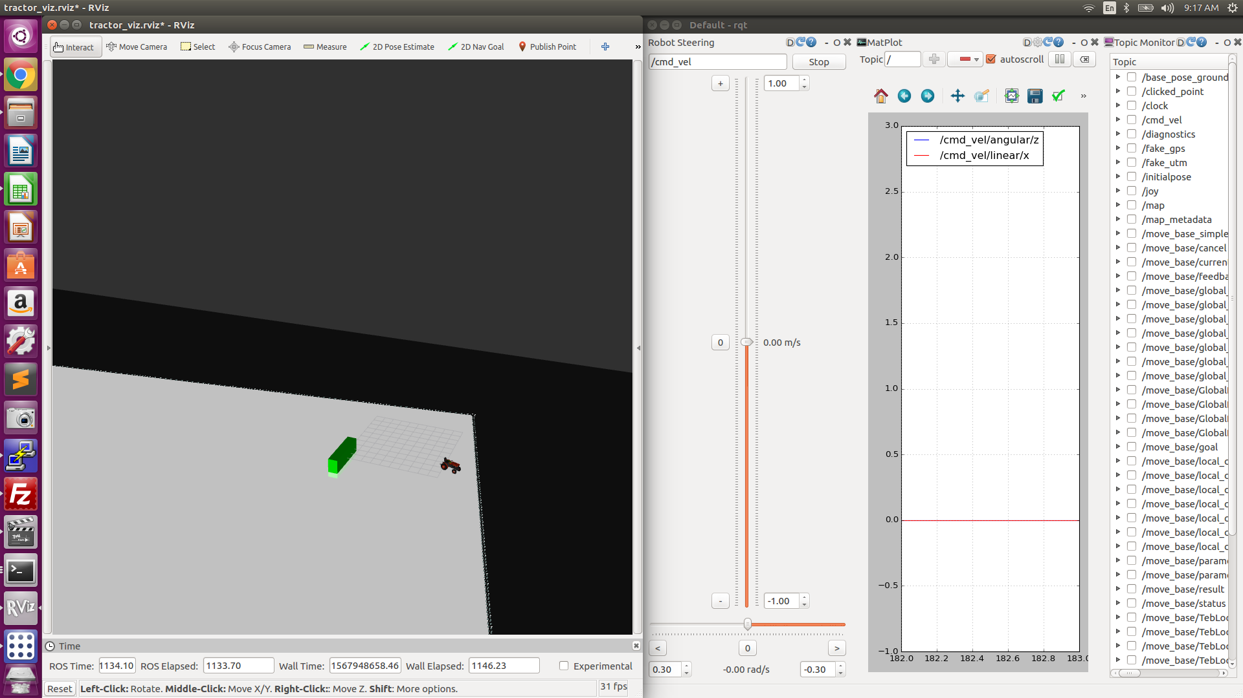

Notes about values:
- /cmd_vel linear.x range is 1 to -1
- /cmd_vel angular.z range is 1 to -1

Capture the tf frames
In a New window
- $ rosrun tf view_frames && evince frames.pdf

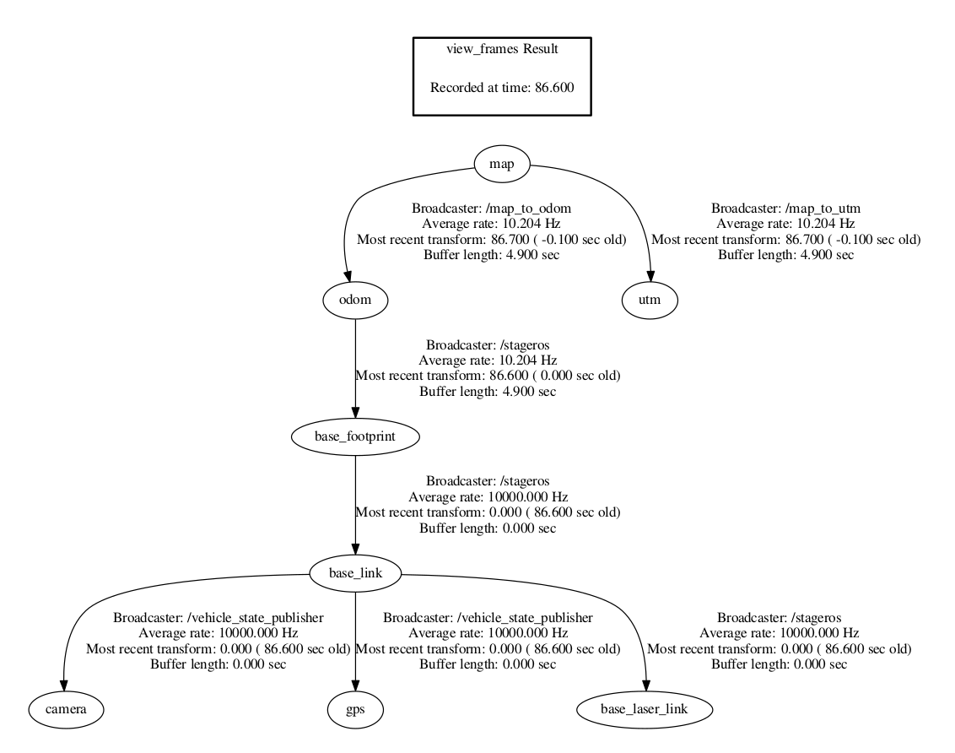

Reference notes:
- Gamepad tutorial link That tutorial is based on indigo. I am using Kinetic.
- Urdf file modelling an ackerman vehicle: https://github.com/jbpassot/ackermann_vehicle/blob/master/ackermann_vehicle_description/urdf/em_3905.urdf.xacro
- Light blog post (Nov. ‘17); Ackermann steering car robot model with simulation in Gazebo: http://ros-developer.com/2017/11/09/ackermann-steering-car-robot-model-with-simulation-in-gazebo/

Control your robot with a joystick in ROS (updates yaml file to create Twist message): http://ros-developer.com/2017/07/28/control-your-robot-with-a-joystick-in-ros/

